Project Report Template

Retail Management Application Using Salesforce

1. Introduction :
   1. Overview :

Customer Engagement: Salesforce provides a unified platform for managing customer interactions, which enables retailers to deliver personalized shopping experiences. With features like Einstein AI and Live Agent, retailers can provide real-time assistance and support to customers, resulting in increased customer loyalty.

1.2 Purpose :

* Automated Sales Processes: With Salesforce, you can automate your sales processes and make them more efficient. ...
* Improved Customer Relationships: With Salesforce, you can keep track of your customers' movements and interactions in a centralized location.

1. Problem Definition & Design Thinking :
   1. Empathy Map :



* 1. Ideation & Brainstorming Map :



3 RESULT :

3.1 Data Model :

|  |  |
| --- | --- |
| Object Name | Fields in the Object |
| Object 1 | |  |  | | --- | --- | | Field label | Data type | | Dispatch/Tracking | text | |  |  | |
| Object 2 | |  |  | | --- | --- | | Field label | Data type | | Dispatch | Checkbox | |  |  | |

3.2 Activity& Screenshot :

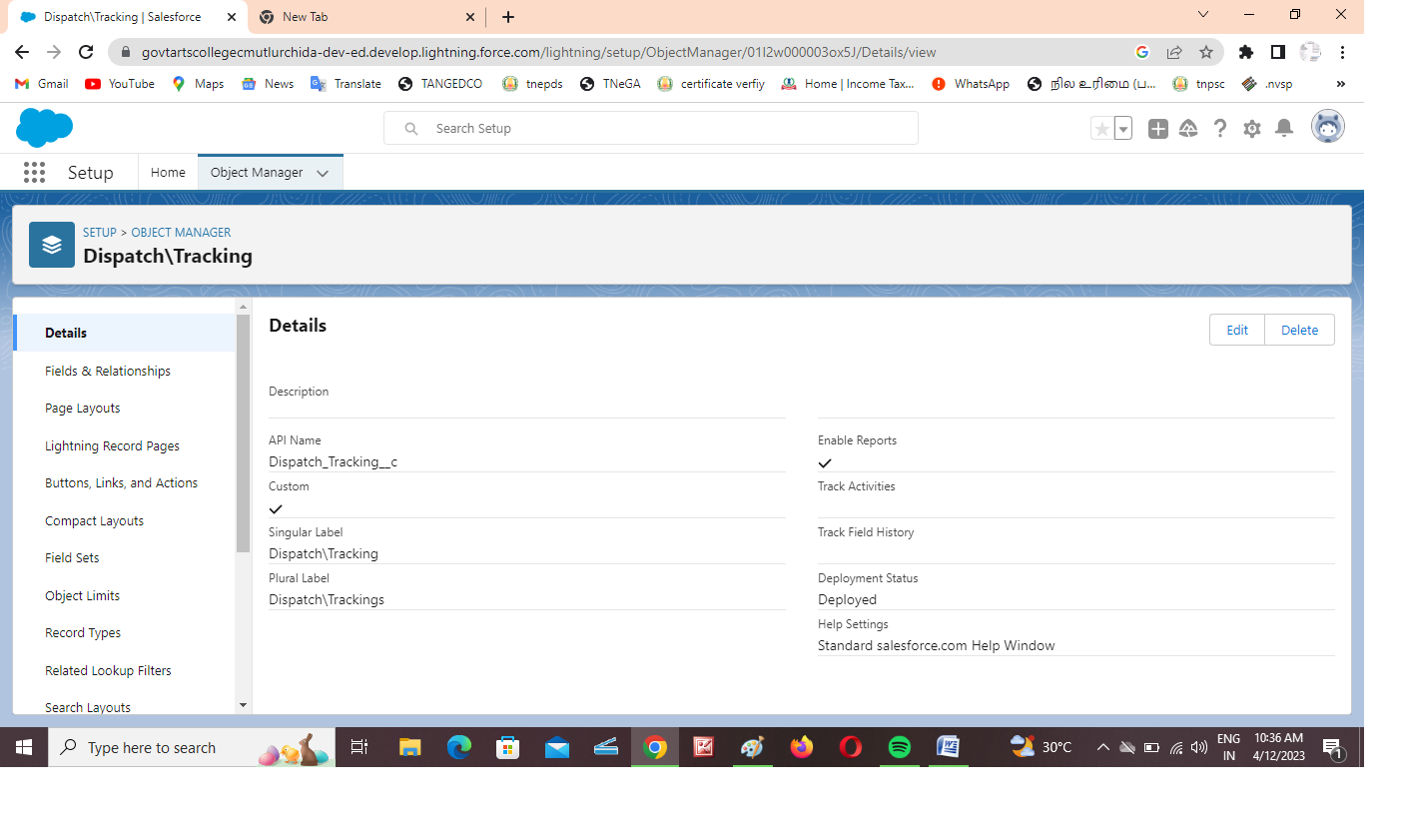

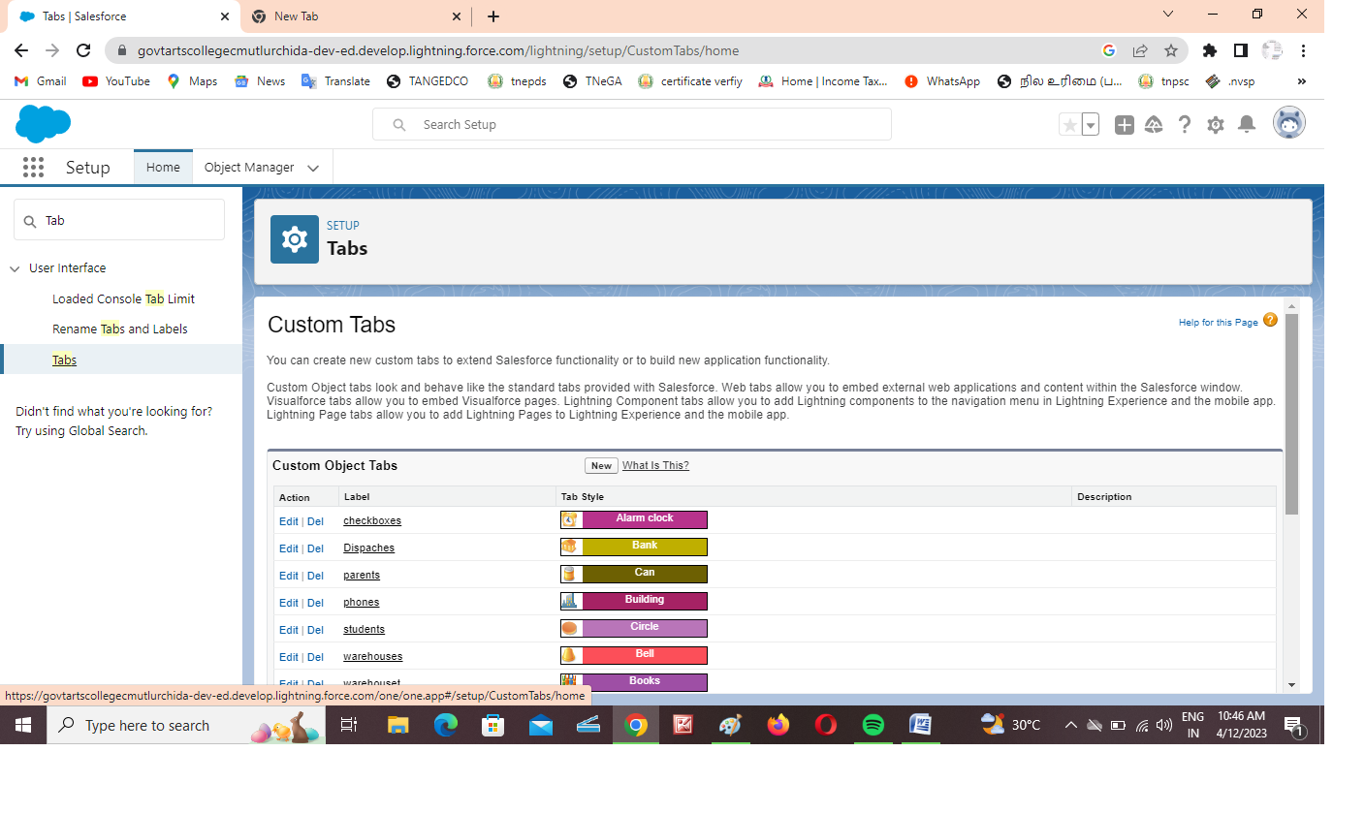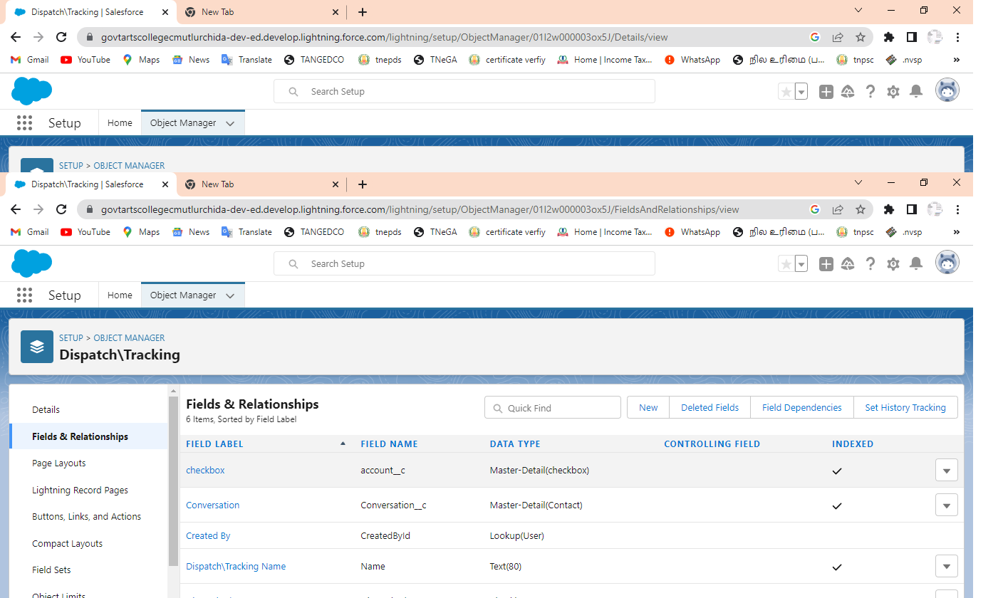

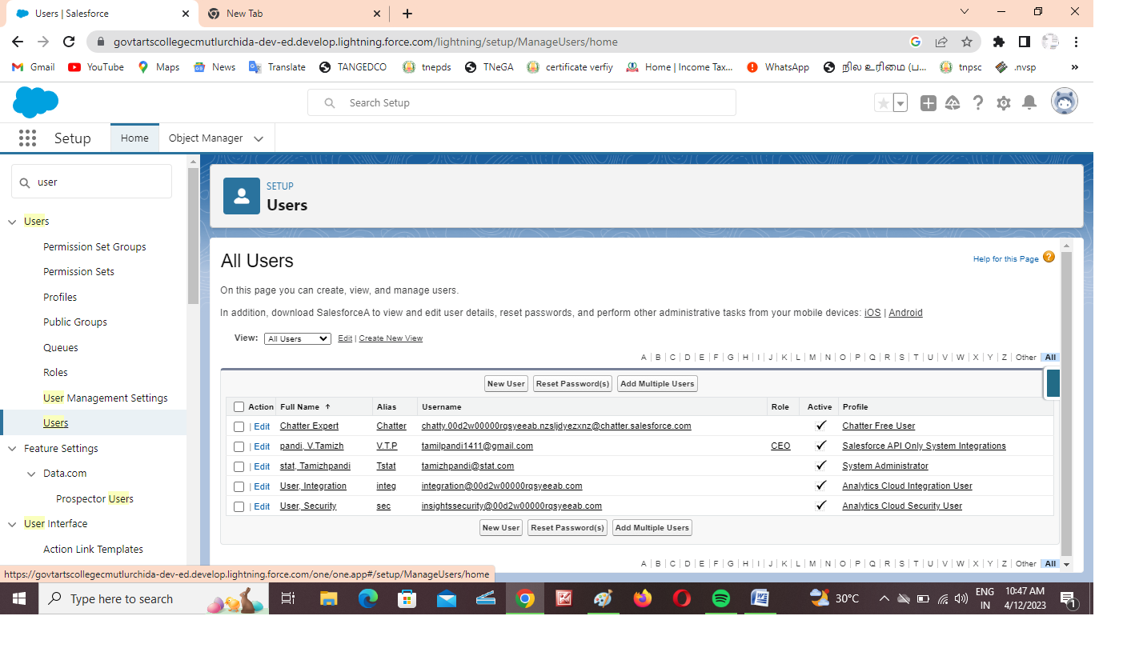

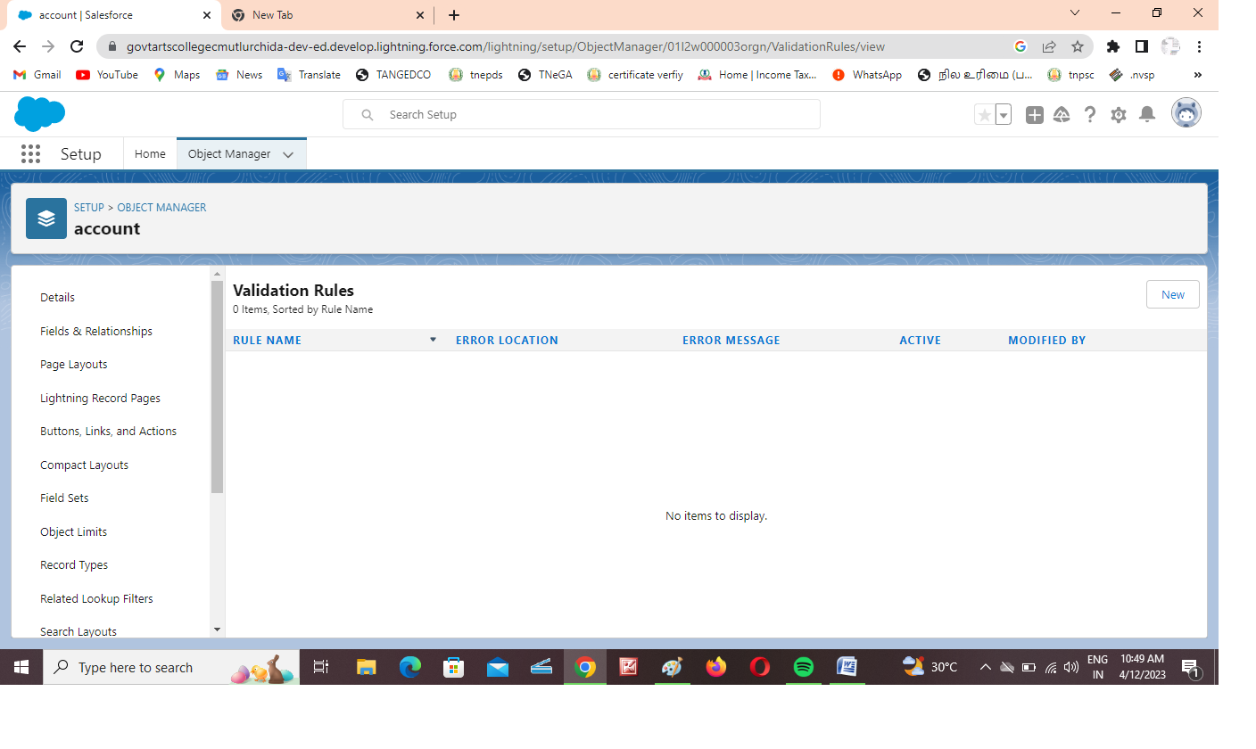

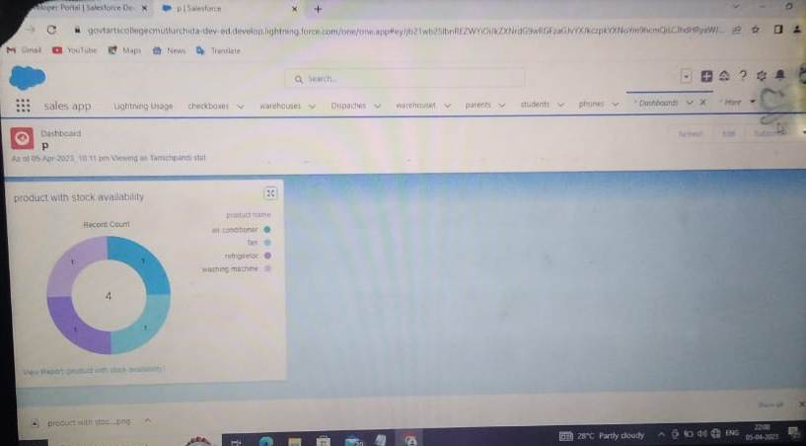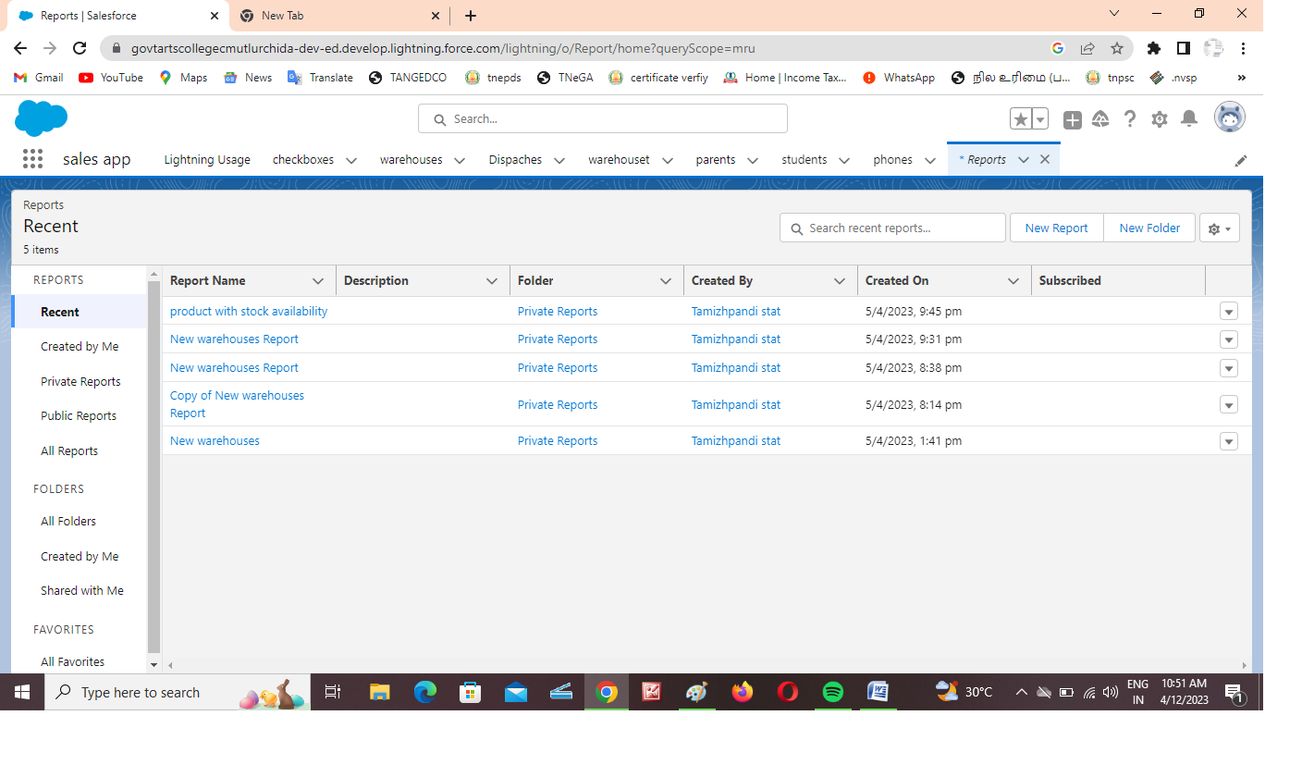

4.Trailhead Profile Public URL :

Team Lead - https://trailblazer.me/id/tstat12

Team Member 1- https://trailblazer.me/id/ttamilvalavan

Team Member 2- https://trailblazer.me/id/subashinip22092003

Team Member 3- https://trailblazer.me/id/svasu133

Project Report Template

5. ADVANTAGES&DISADVANTAGE :

For Salesforce users, your database is likely the hub of most of your daily activities. Between tracking data, running reports, and managing communications, it often seems like your Salesforce system can do it all.

6.APPLICATIONS :

Streamline virtual events with landing pages, registration, video production, on-demand content and hosting - all in one place.

Boost attendee turnout with timely reminders and automated calendar blocks.

Automate your event workflows

7. CONCLUSION :

**Salesforce for Retail**, Salesforce offers a set of solutions specifically tailored to the unique challenges and opportunities facing retailers. These solutions include tools for managing inventory, automating retail operations, personalizing the shopping experience, and analyzing customer data to drive sales and marketing decisions. Some examples of Salesforce products that can be useful for retail include Salesforce Commerce Cloud, Salesforce Marketing Cloud, and Salesforce Service Cloud.

8.FUTURE SCOPE :

Salesforce is the world’s largest cloud Customer Relationship Management (CRM), designed to help you build client interactions, develop apps, and integrate with other systems. If you’re an IT professional looking for a way to specialize in a particular field with promising career possibilities, Salesforce is a go-to choice today.

Salesforce certifications are an excellent approach to developing technical knowledge and skills in the world’s most popular CRM platform. Because the number of end-users on the Salesforce platform is growing, getting started with Salesforce now feels more appropriate and essential than ever. There is a scarcity of highly skilled Salesforce professionals in enterprises and multinational companies.

While exploring what’s in it for me in the Salesforce ecosystem, look at the [Salesforce Admin Career Path](https://www.saasguru.co/salesforce-admin-career-path/) because that is usually the first step for any newcomer.